- Create one VPC, with 1 public subnet and 1 private subnet.
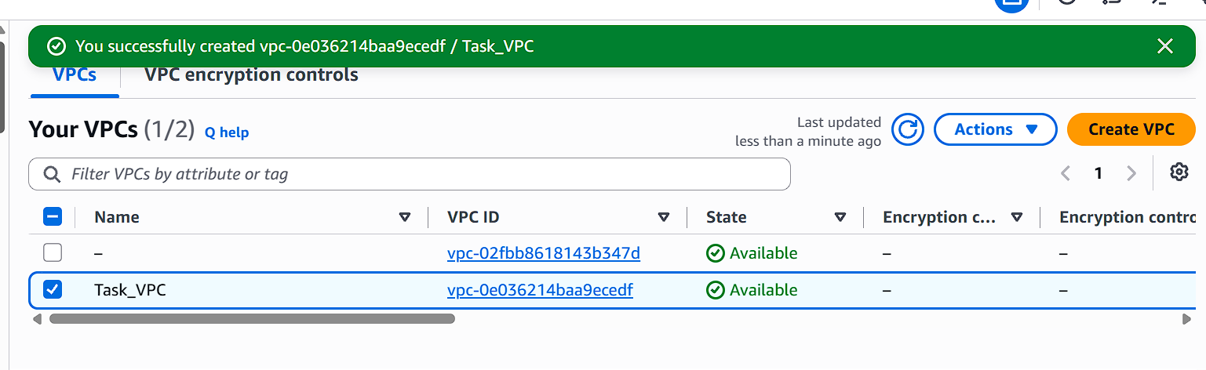
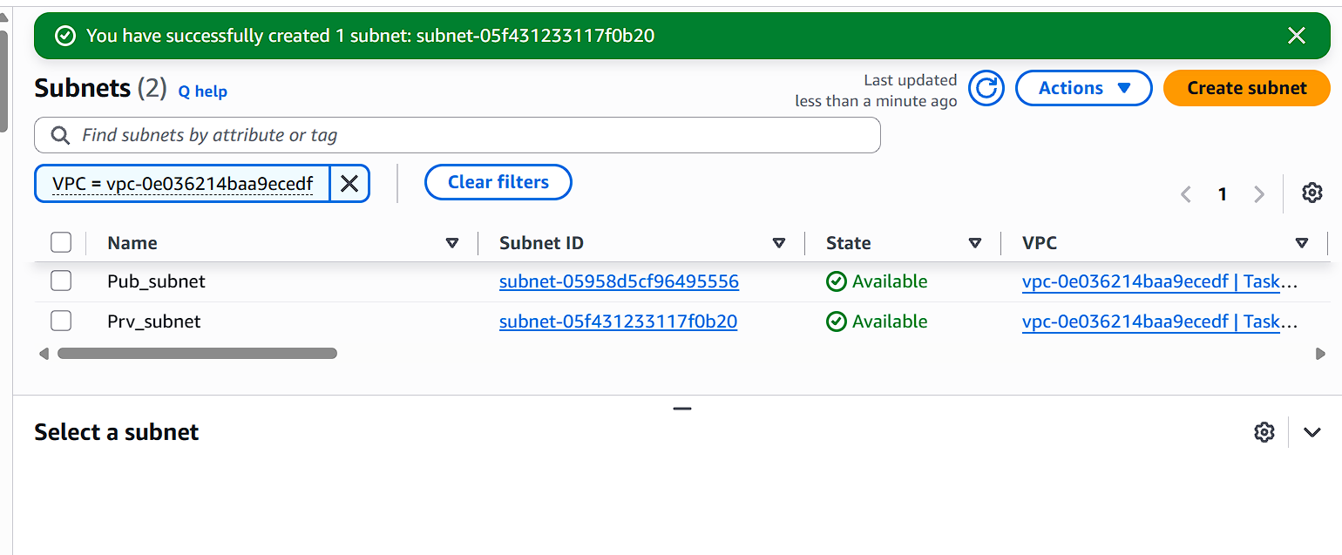
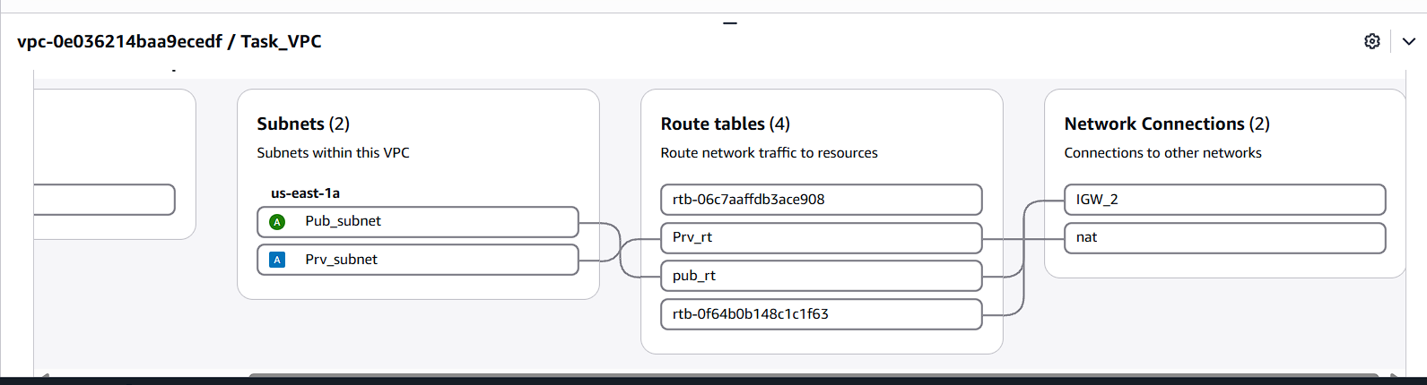
- Enable VPC peering for cross-region.
I have created one pub server in North Virginia region
I created one more Instance in Ohio region.
I am just creating peering connection between two regions.
One main condition is The CIDR range, Will not overlap. (I faced this issue so, I just changed the CIDR range.)
I created peering connection from N.Virgina region and try to accept it from Ohio region.
After this, We need to route this peering connection in both of the regions using CIDR range.
Now, Once try to login N.Virgina region server into local then ping the ohio region region server with the instance private IP.
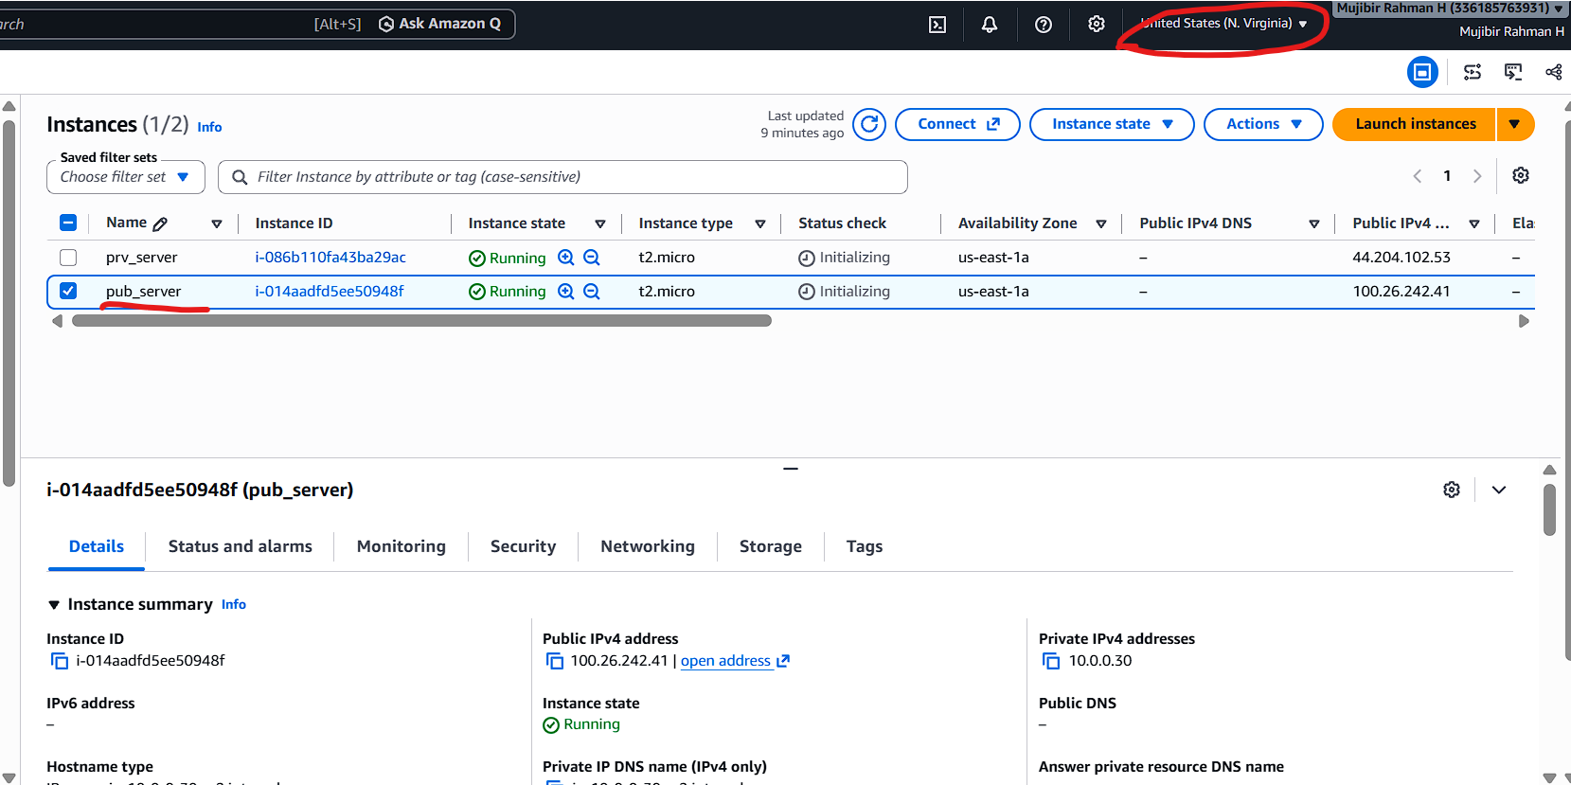
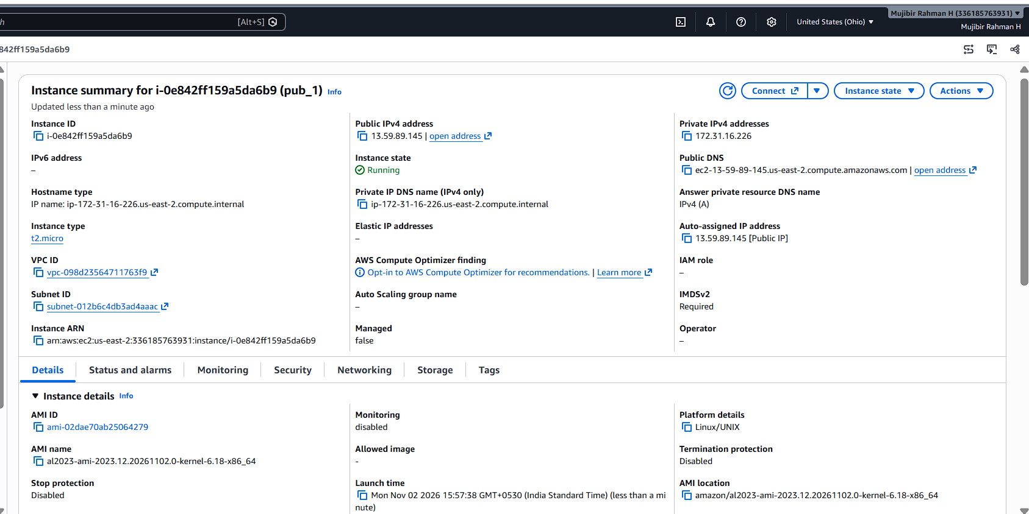
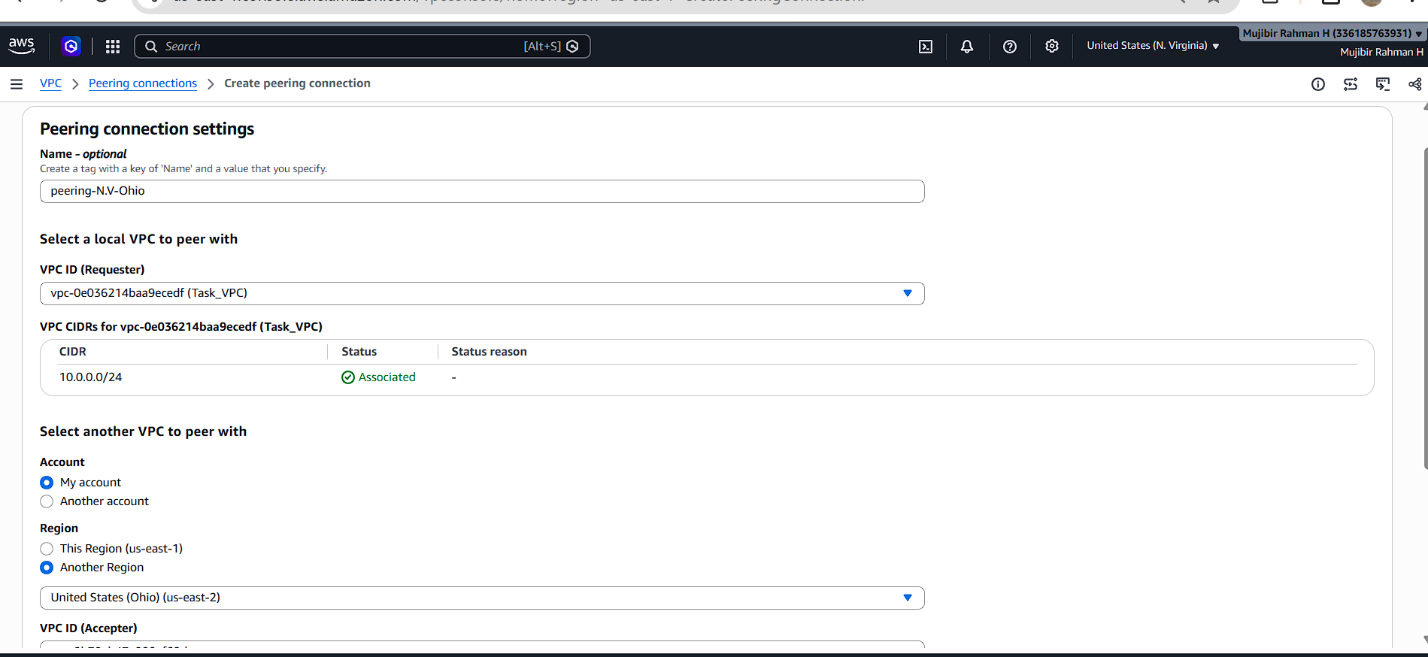
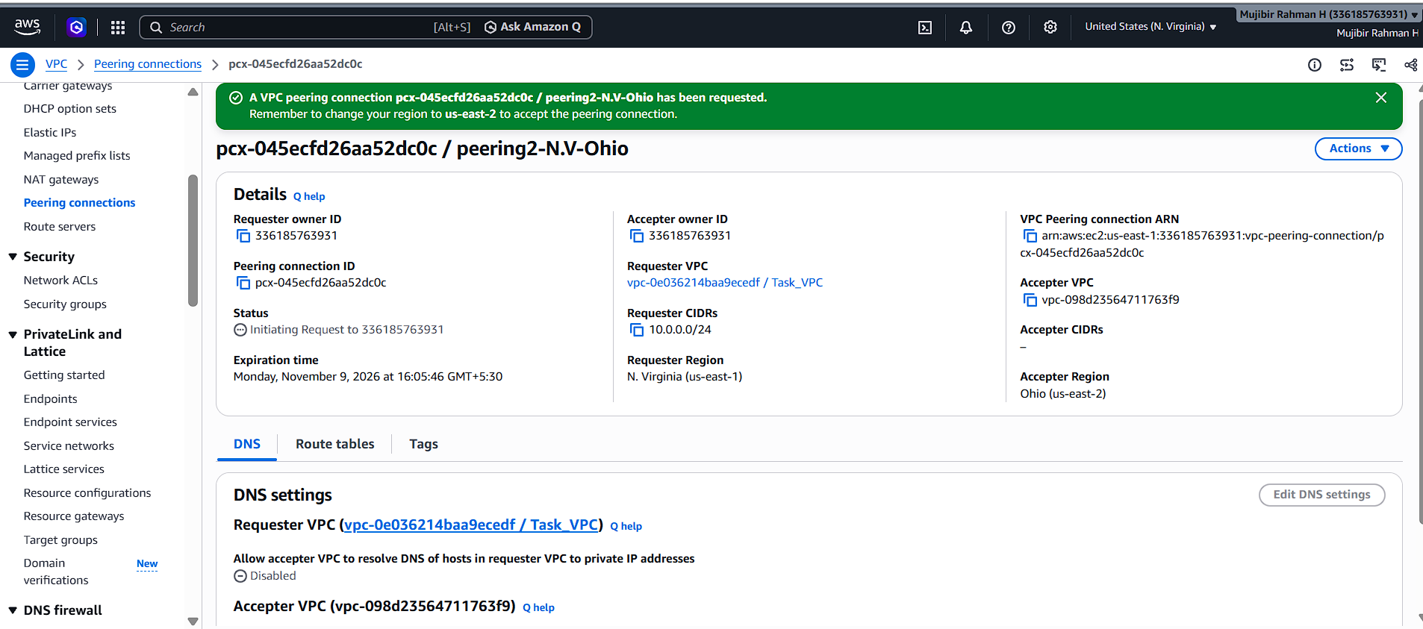
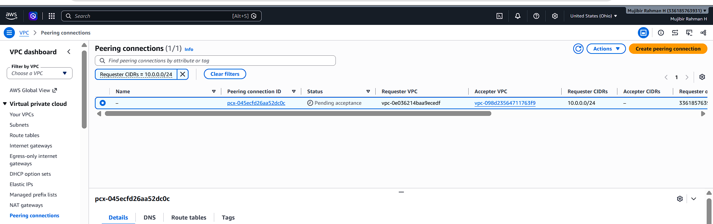
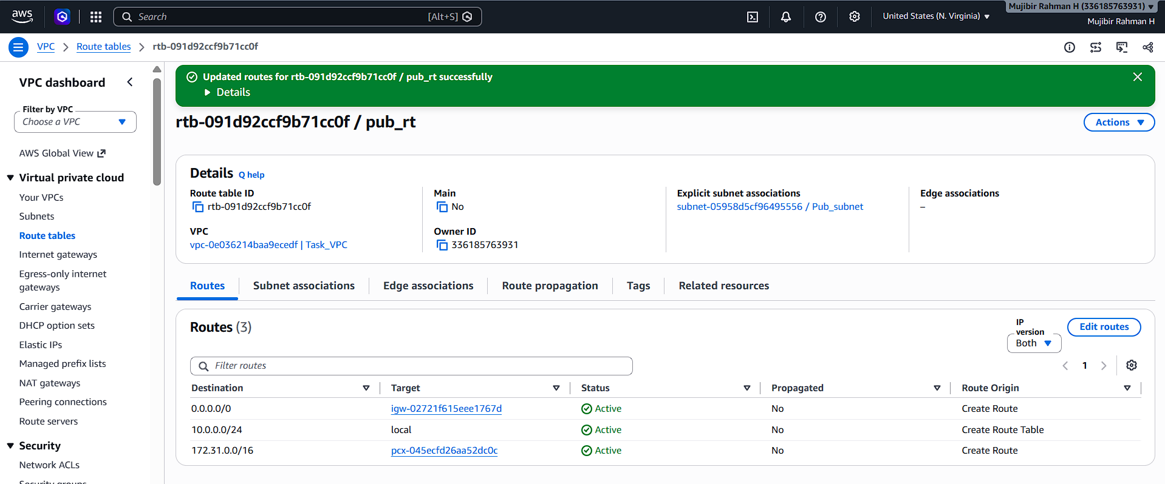
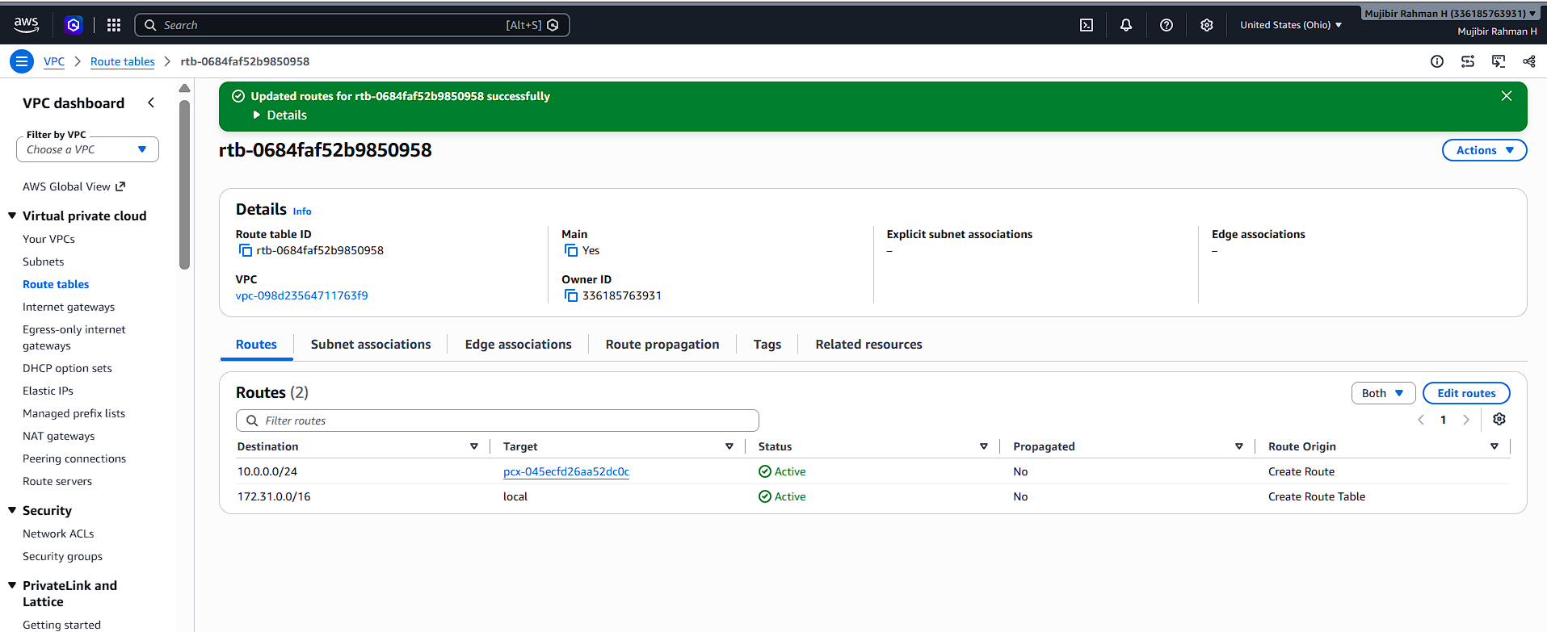
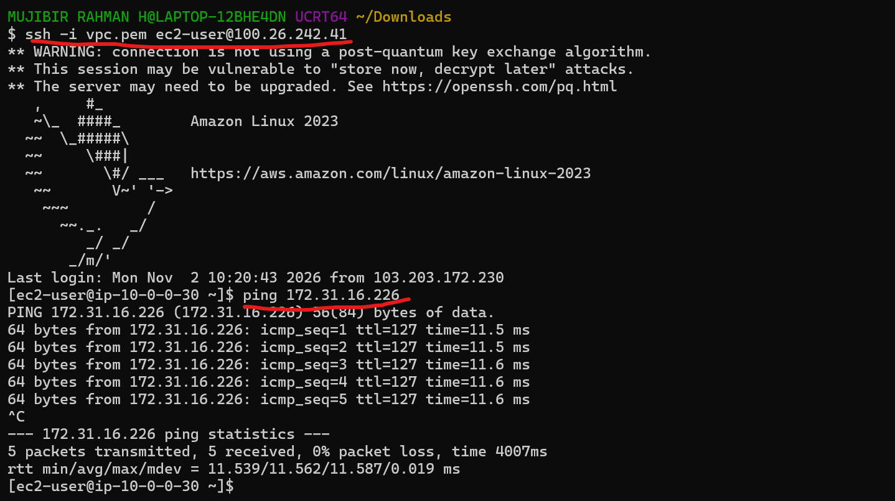
- Enable VPC peering for cross-account (you can collaborate with your friend to do this task).
I just sent a peering connection request to another account.
The peering connection request was accepted by that account owner.
First, I just connected my instance and inside of my ec2 instance checked with private IP of another instance from another account.
It’s directly connected and internet access also there.
Specifically, don’t need to give any route table access for peering. Because we already configured our Route table for that instance from each other sides.
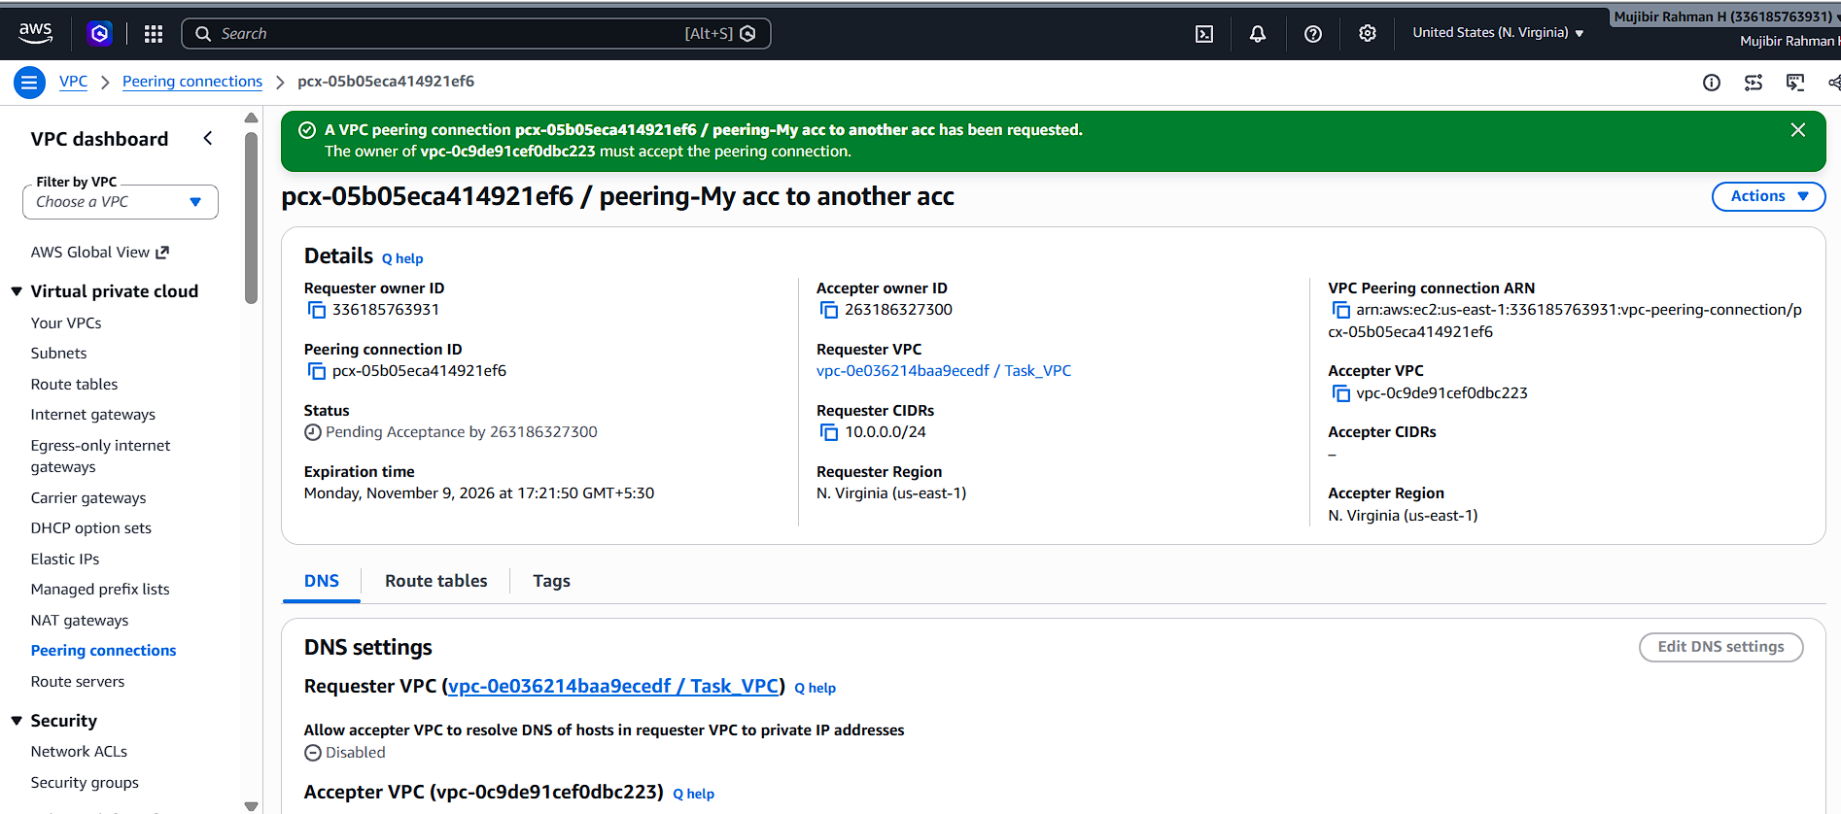
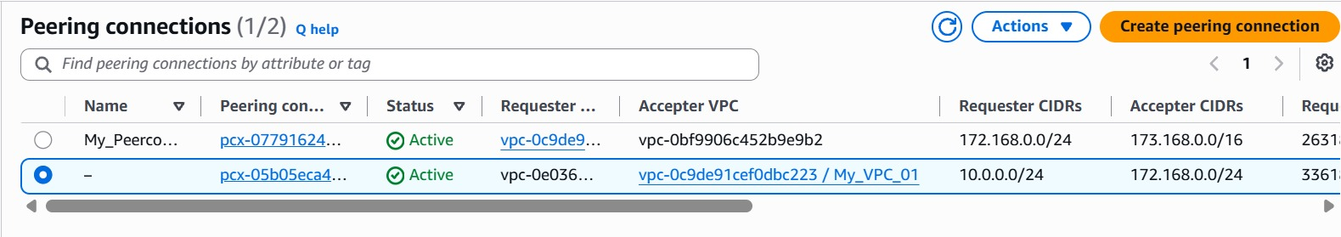
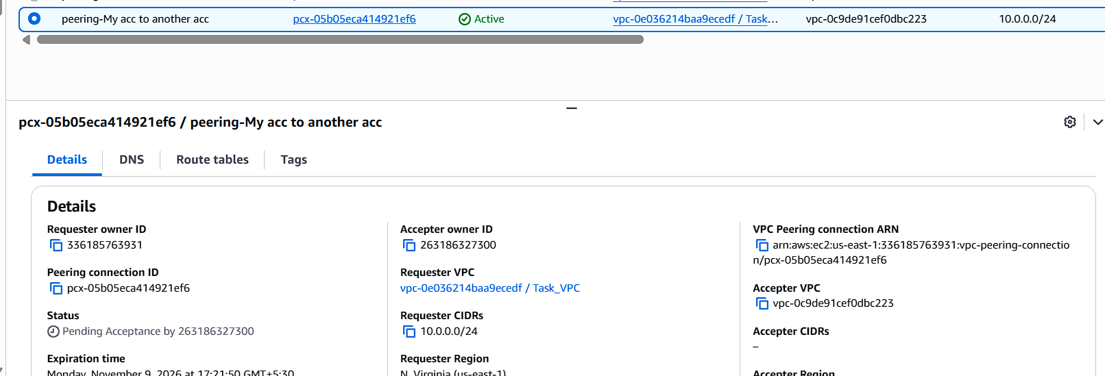
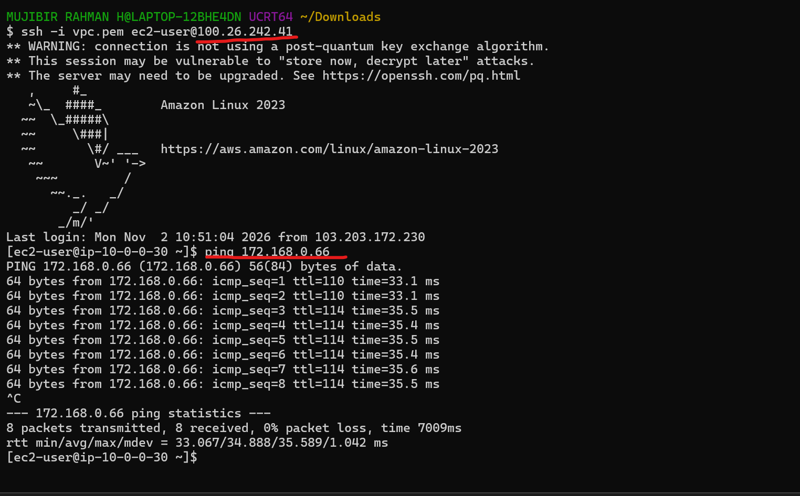
- Set up a VPC Transit Gateway.
Currently, I am not aware of Transit gateway, I just created for the first time.
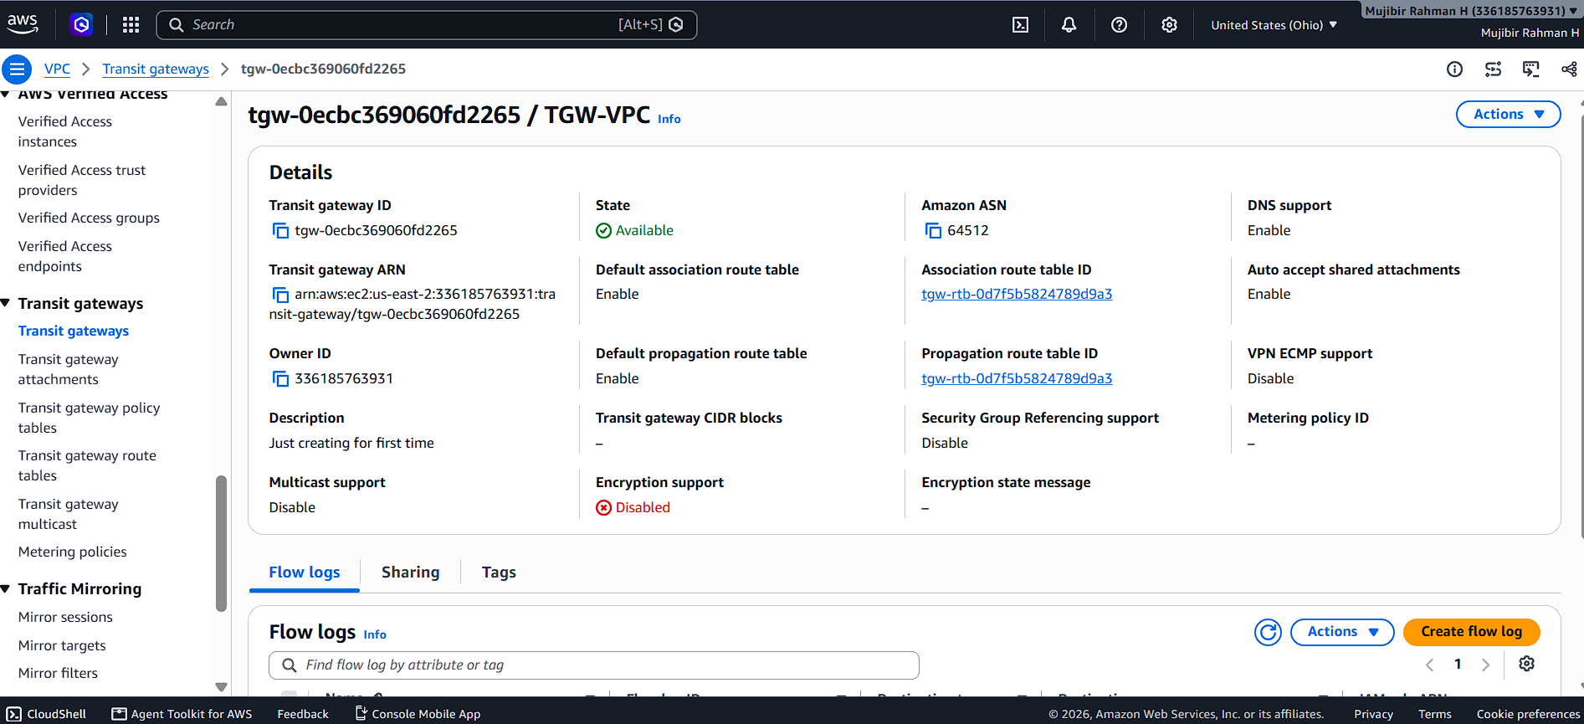
- Set up a VPC Endpoint.
  - I just created the endpoint using S3. Need to know more about this on upcoming sessions.


